Beta - Version
USER MANUAL
(User Manual and Guidelines Documentation)
Project: Chemical Analysis System
Plant: High Chrome Ball Plant
Version: 4.2.0.1
Prepared by: Tsundzukani Nkuna
From Date: 2025/ 05/ 26 To Date: 2025/ 05/ 29

Purpose of User Manual and Guidelines Documentation

- Purpose of the Manual: Explain the goal—how this guide helps users navigate and use the system.
- Overview of the System: Brief description of what the Chemical Analysis System does (data retrieval, display, export, etc.).
- Target Audience: Operators, Technicians, Engineers, Metallurgists.

1. Overview
The system enables users to:
- Search data by Grade, Cast Number, or Date & Time
- View results in a user-friendly format
- Export data to Excel or PDF
- Access Bath and Pit Plotting Charts
- Collaborate and make decisions using accurate chemical data

2. System Requirements

- Hardware Requirements: (e.g., PC with Windows OS, 4GB RAM minimum)
- Software Requirements: (e.g., .NET Framework, and Web browser)
- Access Permissions: Role-based access control (who can view, download, or verify)

4. Navigation Overview
- Describe the main UI layout:
  - Search Panel: Search by Grade, Cast No, or Date & Time
  - Data Grid / Table
  - Charts: Bath and Pit plotting samples
  - Export / Download Buttons
  - Navigation Controls: Links for (Line 1, Line 2 and Line 3, Bath Plotting and Pit Plotting)

5. Using System Features

5.1 Search by Grade
- Enter the Grade in the textbox.
- Click the Search button.
- The system will display records matching the Grade.
5.2 Search by Cast Number
- Enter the Cast Number.
- Click Search.
- The system will display records matching the Cast Number.
5.3 Filter by Date and Time
- Select a date and time range.
- Click Search.
- Table updates with relevant data.
5.4 Viewing Pit and Bath Plots
- Click to chart section.
- Use dropdown or buttons to toggle between Pit and Bath samples.
5.5 Exporting Data
- Click Export to Excel to download a .xlsx file.
- Click Download PDF for a formatted PDF report.
- If no data is present, a message will appear.

6. Troubleshooting & Error Messages

Issue | Cause | Solution
"No Data Found" after search | Invalid search input or no match | Check spelling and try different filter
Application not connecting to database | Network or credential issue | Contact IT / check network
Export button not working | No data in grid | Perform a search before export
7. Process Flow Diagram

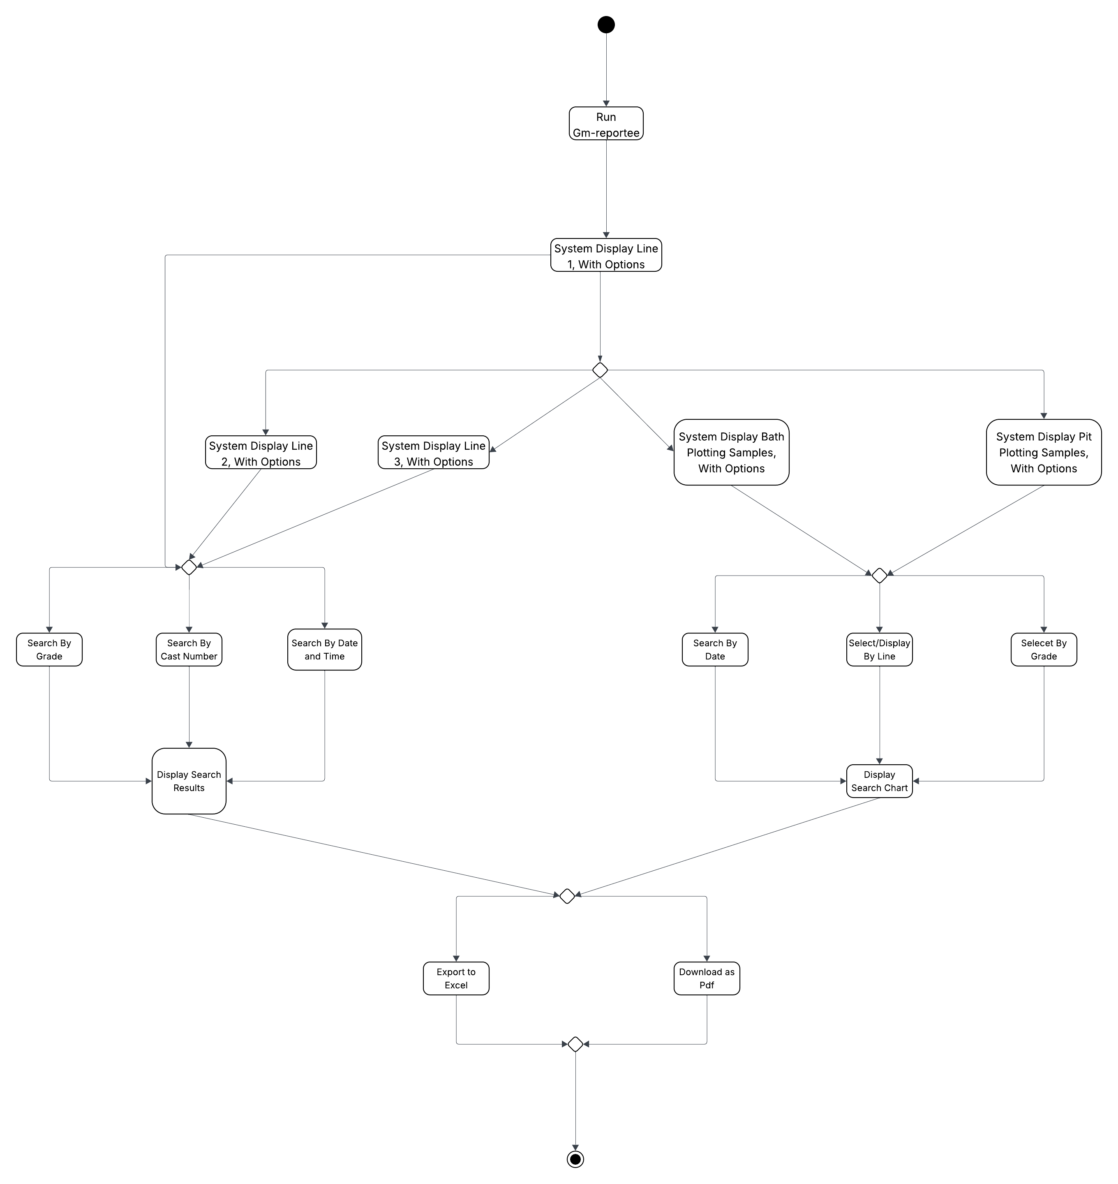

8. Support & Contact Information
- MIS Automation Technician Trainee Email: Martin.Nkuna@Magotteauxgmsa.com
- Maintenance Technician: Tsundzukani Nkuna
- Shift Support Hours: e.g., 7:00–15:45, Mon–Thurs
- 7:00–13:30, Friday

9. Appendix
- Sample Data Format
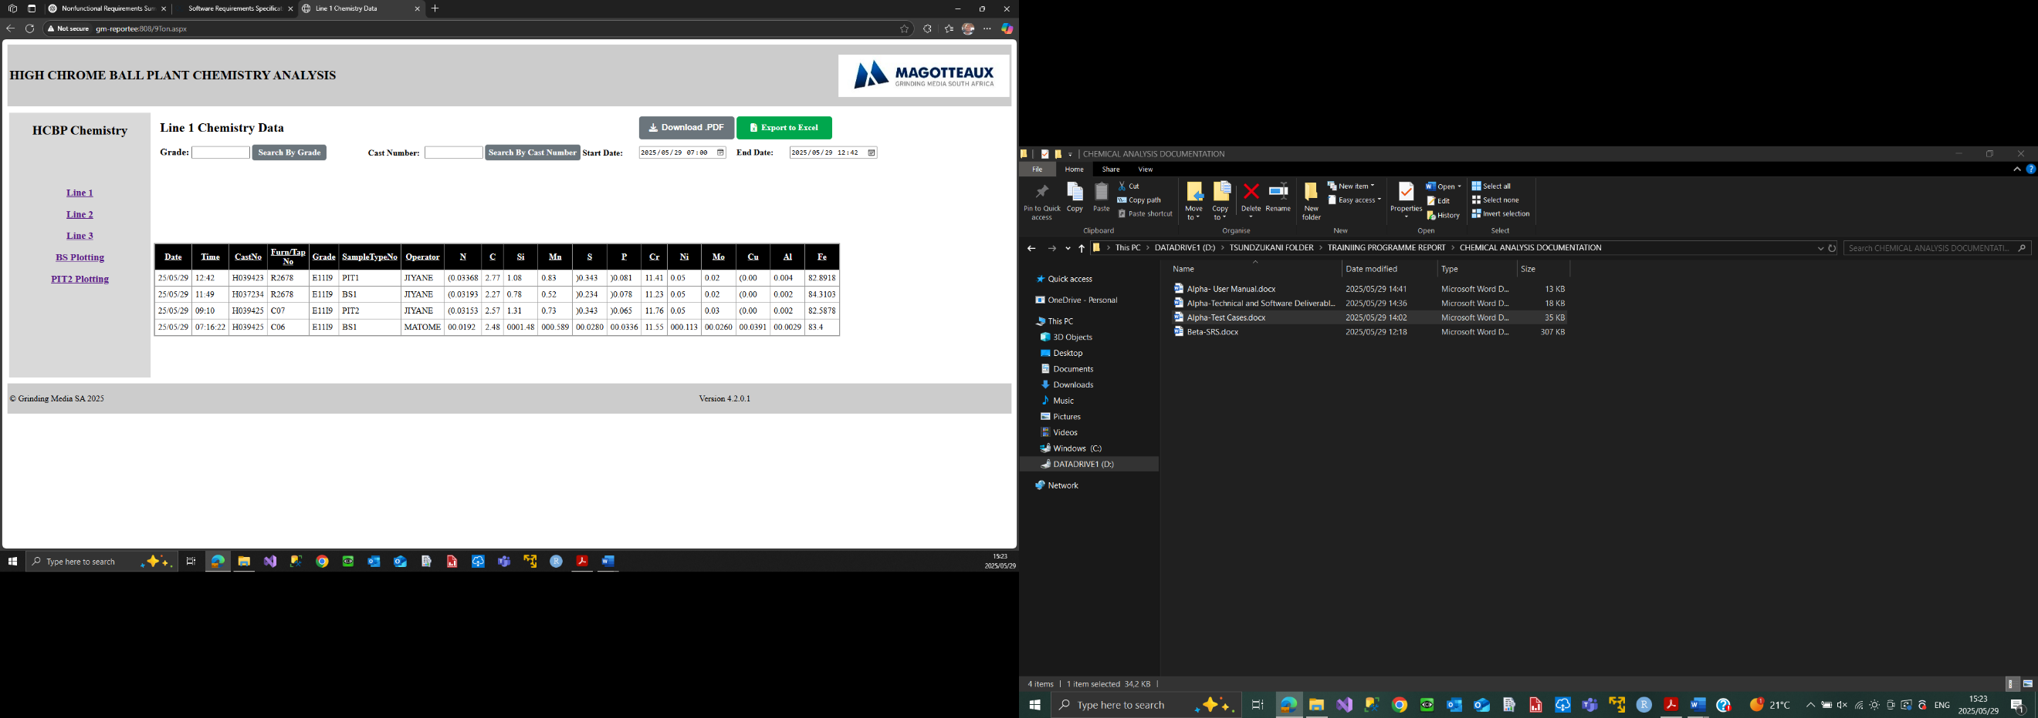
- Chart Interface
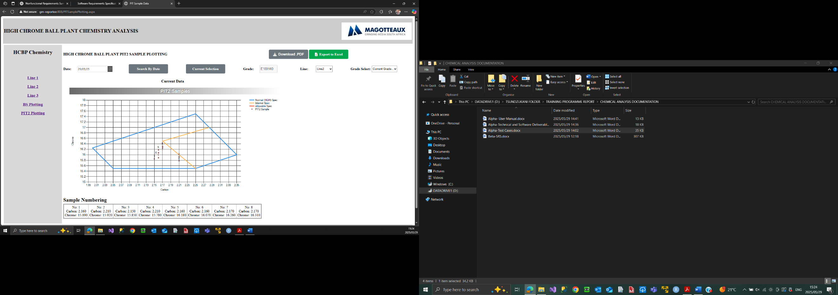

- Exported Data to Excel
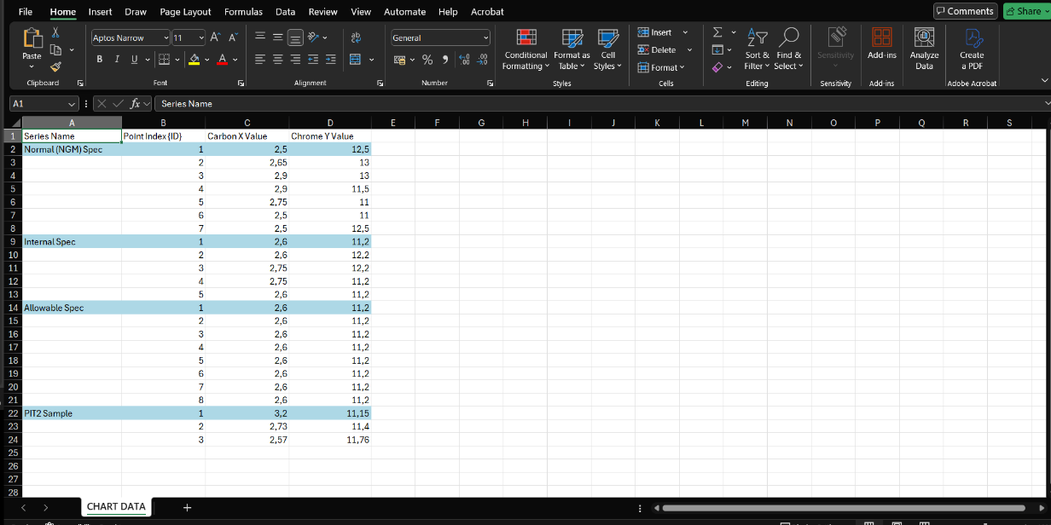
- Downloadable Format
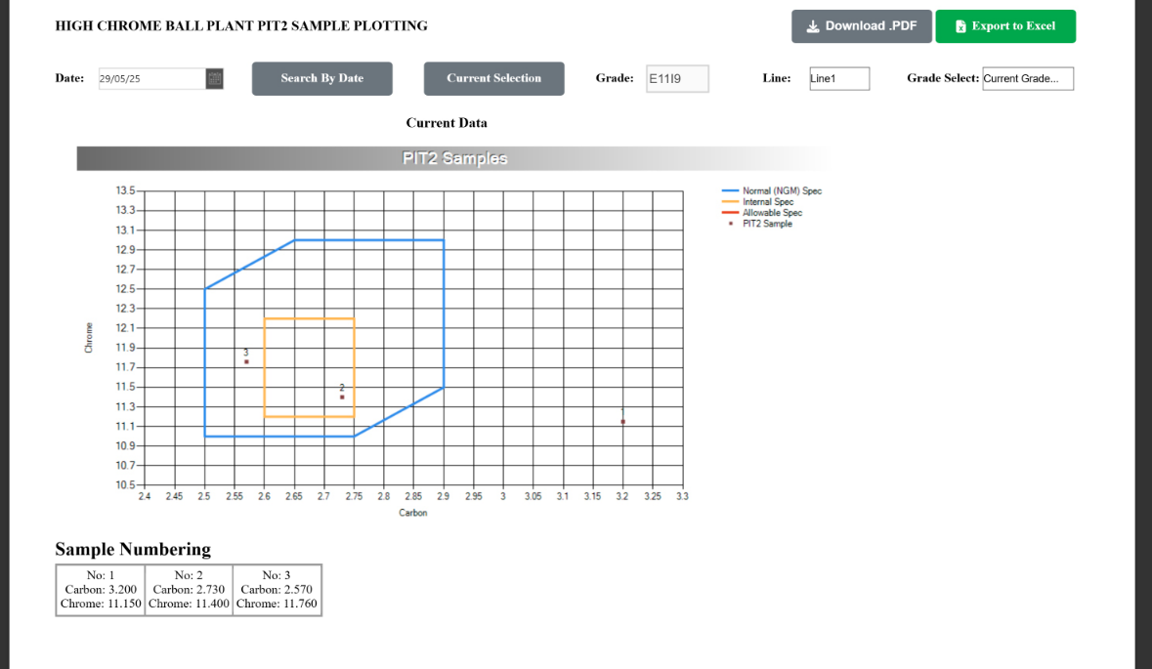

9.Glossary of Terms
  - Grade: Classification of molten metal composition
  - Cast Number: Unique identifier of a production batch
  - Bath Plot: Visual representation of bath chemistry
  - Pit Plot: Graphical analysis of pit chemistry
  - Export: Saving data outside the system as a file

